*WormSpread* User Manual

**Introduction**

This software is meant to simulate the spread of invasive worms over a specified region

**Installation**

To run this software, you need NetLogo (version 5.3.1 or later). You can get the latest version of NetLogo from [here](https://ccl.northwestern.edu/netlogo/download.shtml). Once NetLogo is installed, you can move onto starting the simulation program.

Tip: We recommend you look at NetLogo’s own [user manual](https://ccl.northwestern.edu/netlogo/docs/) to get familiar with the general interface. Click on ‘Interface Guide’ on the left panel in the online manual. We will provide additional information about program specific controls later in this document.

**Starting the Program**

Double click the “worm_sim_main.nlogo” file present in the main ‘worm_simulation’ folder to start the program. This should fire up NetLogo and you will be greeted to the interface tab.

Alternatively, you can start NetLogo and then go to File>Open in the menu bar and open the “worm_sim_main.nlogo” file from there.

**Setting up Folders**

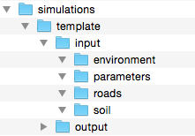If you need to save/load data or import GIS, the software requires a specific folder hierarchy. All simulations will be present inside the “simulations” folder. Each simulation directory will have a main folder, which will have the name that you will use in the program. Sample simulation folders are provided with the program. One of them is shown below:

This will be the name you type in the “save_name” box in NetLogo

All simulations must have these folders following the hierarchy shown

You can use the sample simulation folders for testing purposes and as templates for future simulations. Duplicate the template directory by right clicking on it and selecting “Duplicate”. Replace the top folder’s name from “template” to your desired simulation name. All the inner folders should have the same names as the template’s (shown above). Input data for your simulation will go into these folders as described further down.

**Setting up Input Data**

Please read all directions before beginning to download GIS data. Sample data for the Raquette Lake region is provided with the package. These instructions provide a detailed description of how to download the necessary data and store it properly so the worm simulation can access it successfully. If you would like to reuse some of the data from a simulation, you can copy and paste those folders into the new save folder, then repeat the download process for only the new information.

**Soil**

Below are directions for how to download geo-referenced data about soil from the Web Soil Survey. First, you will download the geo-referenced key values of your unique area of interest (AOI). Then you will compile a key that associates the geo-referenced key with values of soil pH, soil depth and moisture. If you do not download the data and compile your key with the exact same AOI, then it is not guaranteed that the program will work, so it is guaranteed that you do both tasks in the same session.

1. Begin by opening the USDA Web Soil Survey (<http://websoilsurvey.sc.egov.usda.gov/App/WebSoilSurvey.aspx>)
2. After zooming to the area you would like to study, you must select and Area of Interest with the AOI tool on the Interactive Map panel. Try to keep the AOI as close to a square as possible. Note that the Web Soil Survey limits the size of AOI’s.

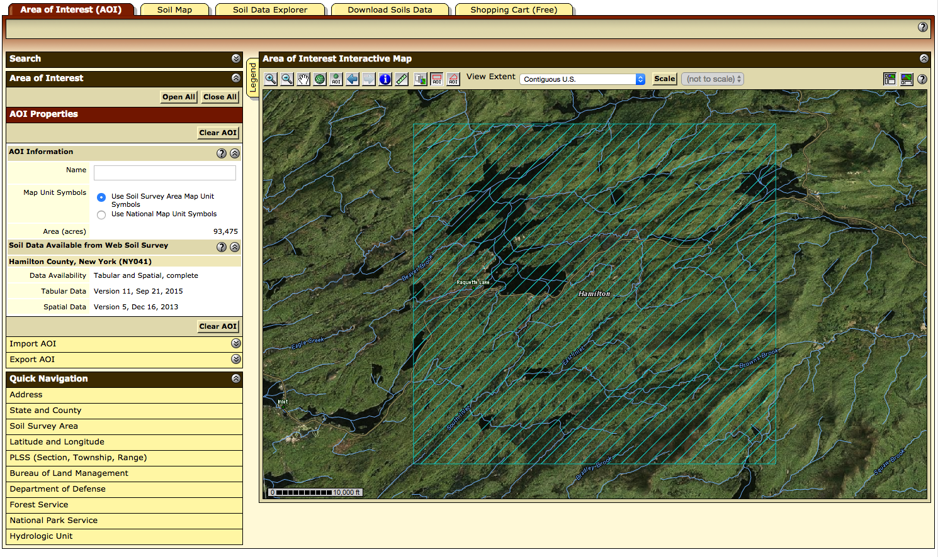

1. Once you have selected your AOI, go to the “Download Soils Data” tab and click “Create Download Link”. Once your download link has been created, download it by clicking.

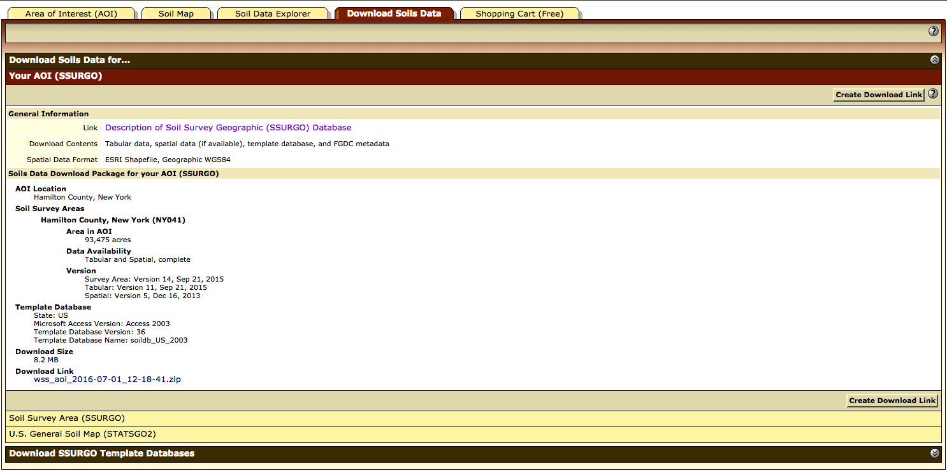

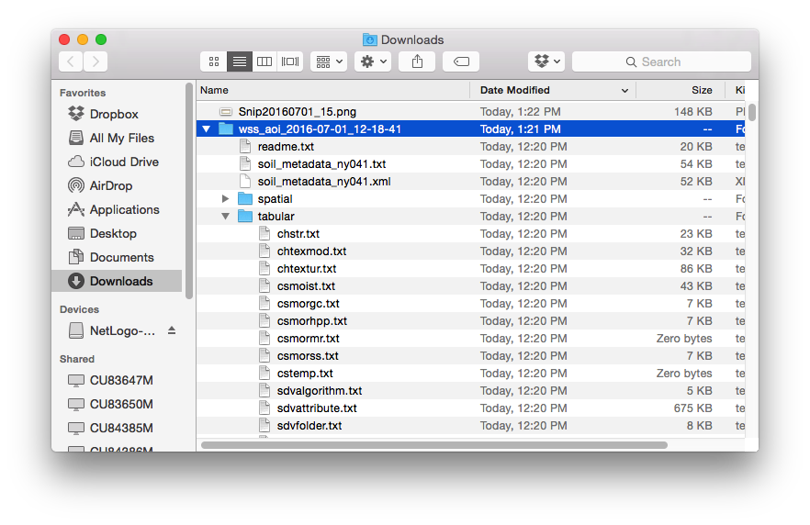

Once the file has been downloaded and unzipped, copy the “spatial” folder from the contents and paste it into the folder: simulations/*save_name*/input/soil/

When you are using a particular *save_name* for the first time, you must create the folder with that name. If you have used a *save_name­­* before, you should delete its contents (though it may be helpful to maintain the folder structure) before saving new data to it.

Note: any time *save_name* is referred to in this document, it should be replaced by the word you will be using in the *save_name* box in NetLogo to refer to the specific simulation that you are running.

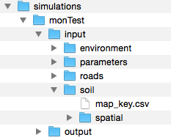

1. Next, you must create the map key. Go to the Soil Properties and Qualities Tab. When you select a trait and press “View Rating”, a table with the values of that trait will appear, as well as a key to understand the symbols on the map. Now begin by creating a file in excel, or another text editor, titled “map_key.csv”:
   1. The first column of the .csv should be the map unit symbol. It is important that this is typed just as it is in the table where it is given (the map unit symbols are case sensitive).
   2. The second column should have the map unit name
   3. The third, fourth, and fifth columns should contain the ratings for the following traits, respectively:
      1. Soil Chemical Properties -> pH
      2. Soil Qualities and Features -> Depth to Any Soil Restrictive Layer
      3. Soil Physical Properties -> Water Content, 15 bar
   4. When completed, save the file to folder: simulations/*save_name*/input/soil

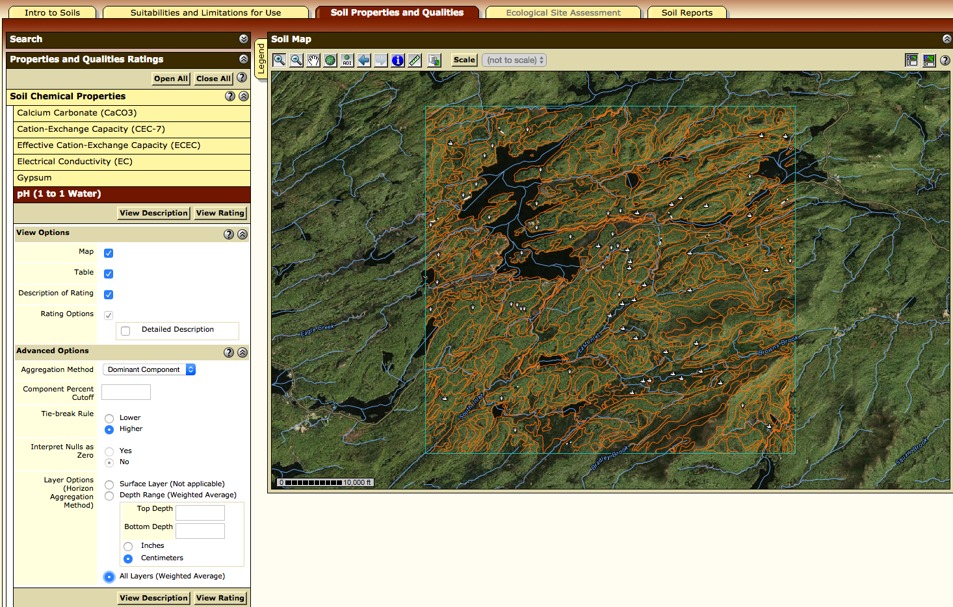

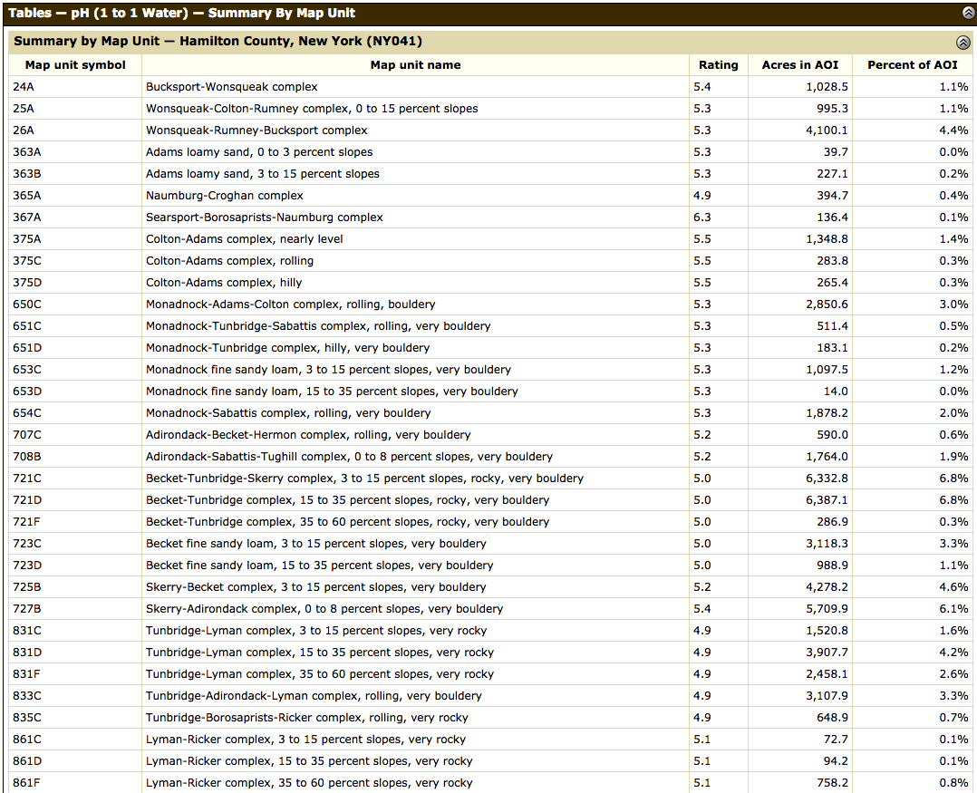

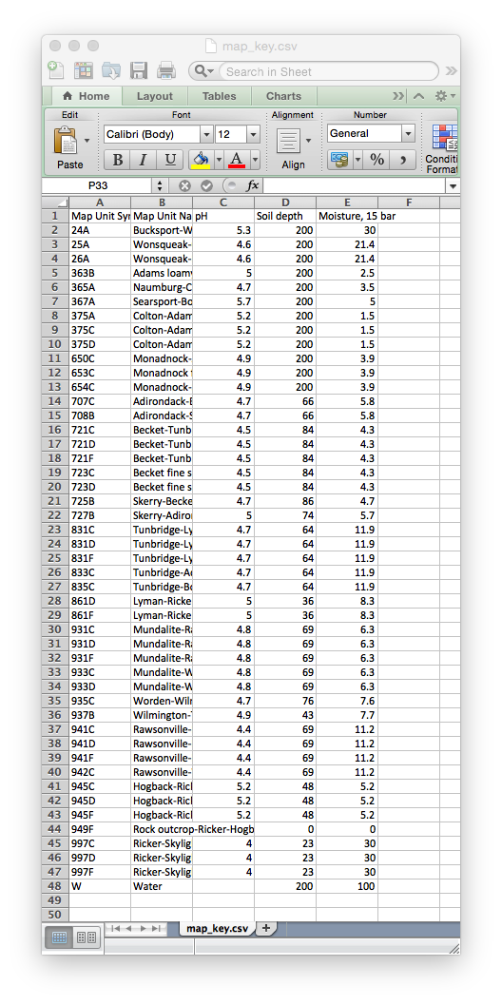

Figure: a sample of how the map_key.csv should be set up

**Temperature**

In order for the simulation to work, you will need data for mean daily temperature over some scale of time. For our sample simulations we obtained historical temperature data from PRISM for the past 30 years. If you would like to change the temperature on certain days for the simulations, you can edit the .csv after you have obtained it.

1. Open the PRISM climate group’s data explorer (<http://prism.nacse.org/explorer/>)
2. Find the area that you want data for within the explorer, and select a grid within it by clicking on it
3. Adjust the settings in the window to match the settings in the picture below, within your chosen region. The start date should be January 1, but the year is up to you, depending on when/how long you would like to simulate.
4. After you have chosen the correct settings, click “Retrieve Time Series” then click “Download Time Series”
5. Once the data has been downloaded as a .csv, save it as “temperaturelist.csv” in the folder: simulations/*save_name*/input/environment/

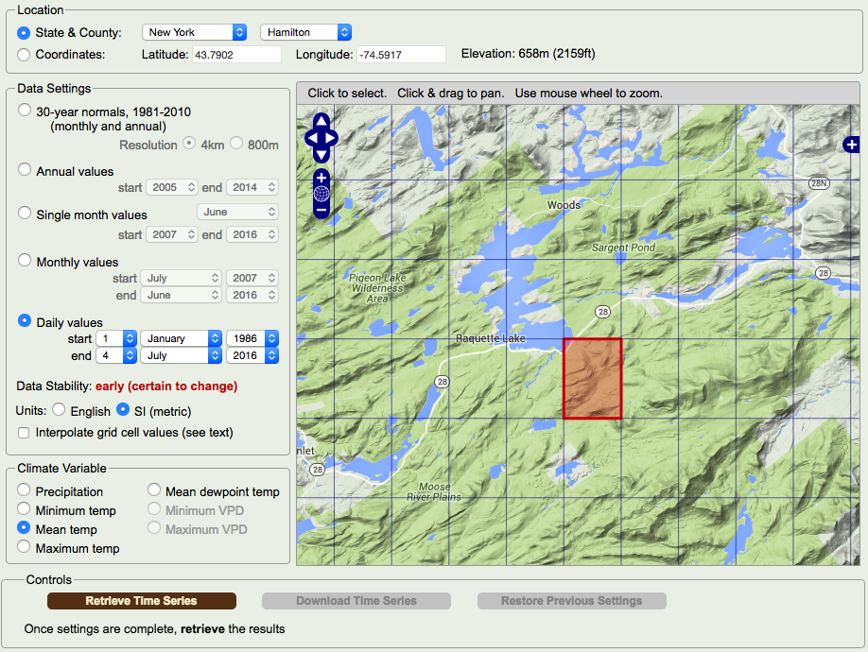

Highways:

For incorporation of major roads, we have included the ability of the worm simulator to use GIS data. There is a file available with all highways in the United States. Once you have this dataset, you can copy and paste it from one save file to another every time. If you would like to model an area extending outside of the United States, you will need to find another dataset, but the compatibility of this feature is not assured.

1. Go to the following URL to download highway GIS data <http://nationalmap.gov/small_scale/atlasftp.html?openChapters=chptrans#chptrans>
2. In the table, pull down the “Transportation” tab and find the “Roads, One-million Scale” data then download the shapefile.

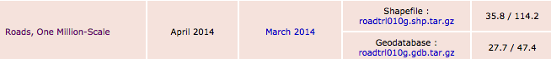

1. After downloading, copy the contents of the download to simulations/*save_name*/input/roads/ (as shown below)
2. If you have copies of the files already saved for other simulations, they can be copy and pasted into the same file path of a new *save_name*

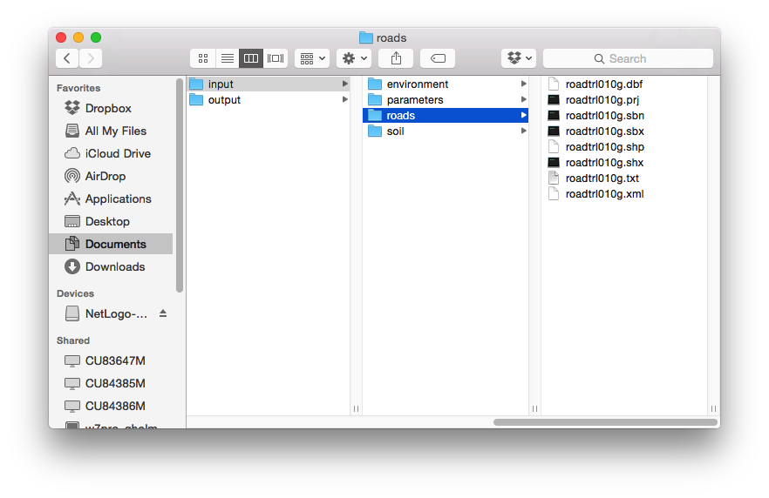

Figure: How the contents of the roads folder should appear

**Setting up a Simulation**

Once all the files are in the correct folders, we can start a simulation from NetLogo. The following steps will guide you through running a simulation. We will use “testSim” as a name for our simulation but you may use the name you chose.

1. Click Initialize
2. Click Load GIS

Note: This may take some time depending on your machine

1. Enter the command *initialize_monitors* into the Command Center at the bottom

Note: This step will add preset monitors to the simulation. You may choose to skip this step and add your own monitors and save their names. For more information, look at the **Monitors** section of the Environment controls.

1. Click Save Environment

Note: This is to save the environment for faster loading in the future.

1. Under *Species Control*, click on the *species_number* drop down menu and select “1”
2. Slide the *worm_population* slider to 25
3. *ph_tolerance, temperature_tolerance,* and *species_genetic_diversity* should be set to zero and *insertion_frequency* should be set to 0
4. Set the *speed* to 0.5

Note: This speed should ideally be calculated according to the dimensions of the region you are simulating.

1. Click Add
2. Click on any point on the map

Note: This will add the worms onto a single point on the map. Alternatively, you could select a region and add them randomly. For more information, look at the Environmental section.

1. Click *Save* under *Species Control*
2. Enter 10 into *number_of years* text box
3. Click on Go

You should see the simulation start and run for 10 years. Once it finishes, it will store all the data collected into the output folder in your simulation directory.

Tip: Next time, if you want to load the same simulation environment and agents, you only need to click on *Setup Simulation*

**Running Multiple Simulations**

We will now look into a tool called *BehaviorSpace* for running multiple automatic simulations.

1. Delete everything from the output folder in your simulation directory
2. Click on Tools in the Menu Bar
3. Select BehaviorSpace
4. Click New
5. Type in test as the experiment name
6. Delete everything in the text box holding all the variables
7. Type in the following text instead (do not copy/paste): [“ph_tolerance” 0 0.1]

Note: This will run two simulations, one with *ph_tolerance* as 0 and the other with 0.1

1. Set *Repetitions* to 3
2. Add the following command to *Setup Commands:* setup_bs (delete anything that is already there)
3. Click OK
4. Select *test* from the BehaviorSpace menu and click Run
5. Make sure *Spreadsheet output* and *Table output* are unchecked
6. Click OK

The simulations should start running now. You can increase the slider from *normal speed* to the right to make the simulations run faster. After the simulations are done, we can look into plotting the results.

Note: Any value not changed in BehaviorSpace will be used from the program’s Interface screen

**Plotting Results**

You will first need to open the main folder where the program resides. (go to directory?)

1. Open simParams.txt
2. Delete everything if it is not blank
3. Enter a line with the following format:

*<save_name> <repetitons> <BehaviorSpace argument>*

Ex: testSim 3 [“ph_tolerance” 0 0.1]

**Copy/Paste** the “Vary variables…” argument from BehaviorSpace. Typing it may produce errors. If you have multiple arguments for variables in BehaviorSpace that you want to plot, each argument should be on its own line of simParams.txt with the same *<save_name> <repetitons> <BehaviorSpace argument>* format.

Note: The format for plotting parameters will always be the same.

1. Save the file and exit
2. Double click *plot.command* in the main folder

You should now see a bar chart showing densities across five regions for the two different pH tolerance levels

Tip: You can use the directions above to help you plot images for temperature tolerance, genetic diversity and number of random insertions.

**Comparing Simulations**

If you plan on running simulations with different environments (including obstacles such as roads) and plotting their results, you will need to run two different simulations and then plot them. This will require a different format for BehaviorSpace arguments. The steps below outline how a simulation could be run for testing the impact of future road construction on the spread of worms over a region.

1. Create a simulation directory named “defaultRun” and fill it with all the original GIS data and parameter tables required for a normal simulation

Tip: It is recommended to keep a ‘default’ directory at all times for control purposes and as backup

1. Create a copy of the default simulation directory and name the new one “roadTest” (we will edit this to create a map with more roads)
2. Start the program and type “roadTest” in the *save_name* box
3. Click Initialize, Load GIS then Save Environment
4. On the top (next to the speed slider) change updates from *on ticks* to *continuous*
5. Click on the *change* dropdown menu and select *highway*
6. Under *Environmental Controls* click Draw to begin drawing
7. Using your mouse, draw roads where desired on the map

Note: Draw slowly; otherwise you will see gaps in the road

Tip: At any point if you need to reset the map, click on Load Environment

1. Click on Draw again to stop drawing
2. Click Save Environment
3. From *Species Controls,* add worms and click Save
4. Type in “defaultRun” in the *save_name* box
5. Click Initialize, Load GIS then Save Environment
6. Add worms and click Save

Tip: Adding worms in the same place as in roadTest will allow for a better comparison (you can assure that worms are being placed in the correct spot by using the insert_worms function, detailed in the user manual).

1. Open BehaviorSpace
2. Create a new experiment and name it as desired
3. In the Vary variables… text box, enter (with quotations)

[“save_name” “roadTest” “defaultRun”]

Note: The format is [*“save_name”* <first sim> <second sim> … ]

Setting “save_name” as the first argument allows the user to run different simulations from their respective directories. This experiment will run roadTest first and then defaultRun using the values saved for these simulations.

1. Make sure the Setup Command is *setup_bs* and click Ok
2. Run the simulation and plot it as previously described steps

**Interface Guide**

**Program Controls**

This section of the guide will look at controls specific to the program

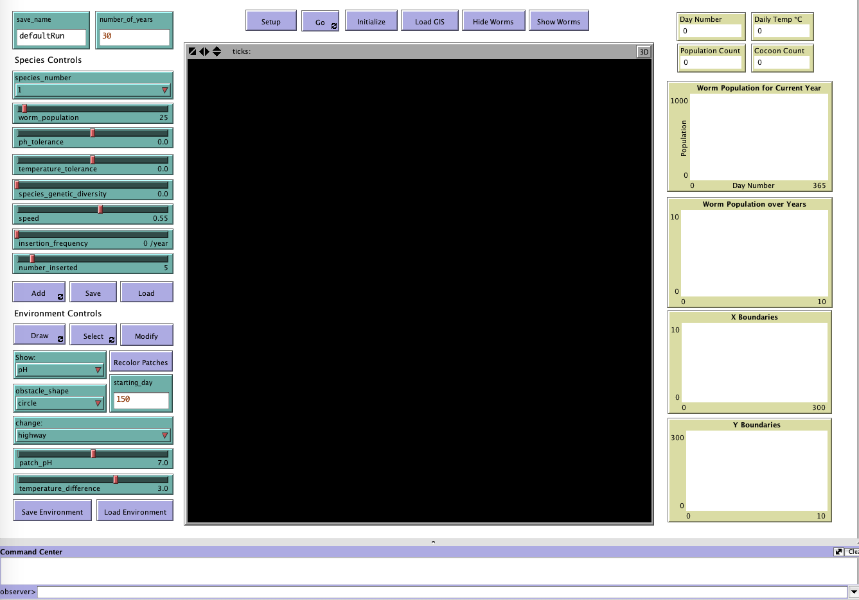

Figure : Graphic user interface of WormSpread

1. Simulation Parameters:
   1. *save_name*: The name of the simulation, this will tell WormSpread which files to use when saving/loading agents and the environment.
   2. *number_of_years*: The number of years that the simulation will run for.
2. Simulation Controls:
   1. Setup Simulation: Initializes global parameters and loads all data from files associated with *save_name*, including worms/cocoons, the environment and all of their state variables.
   2. Go: Runs the simulation. If the button is black, it is indicating that it is on, and will continue to run until it is pressed again.
   3. Initialize: Initializes default parameters and loads weather data and mortality functions. Use this button when initially setting up a simulation from GIS data. In order for this function to work properly, the “parameters” folder must be pH-table.csv, temp-table.csv, and temperaturelist.csv must be in the proper format in their proper locations in the file directory.
   4. Load GIS: Users can call Load GIS after using Initialize. As long as GIS data has been set up in the proper folders, this button will result in a geographically accurate representation of your selected region in NetLogo.
   5. Hide Worms: Makes the worms in the simulation invisible to the user. The worms will still continue their processes in the background and the results of the simulation will be unchanged. This is useful if the user wants to see the underlying traits of overpopulated regions in a simulation.
   6. Show Worms: Makes worms that are hidden visible again.
3. Species Controls:
   1. *species_number*: Refers to which set of traits worms added with the “Add” button will have. If the trait sliders are not the same when a second set of worms with the same species number are added, they will take the set of traits given to the original worms with that species number.
   2. *worm_population*: When worms are added, with the “Add” button, *worm_population* is the number of worms that will be added.
   3. *ph_tolerance*: Adjusts the worms’ mortality due to pH. Ex: if a worm has a pH tolerance of 0.1, it will have the same mortality due to pH at a pH of 6.6 that a normal worm does at 6.7. A worm with a pH tolerance of -0.1 will have the same mortality at a pH of 6.6 that a normal worm has at 6.5. Effectively, the higher the pH tolerance, the less likely a worm is to die due to the acidity of a soil. Only applies to the worms of the species number being added.
   4. *temperature_tolerance*: Adjusts the worms’ mortality due to temperature. Ex: if a worm has a temperature tolerance of 1**°**C, it will have the same mortality due to temperature at a temperature of 20**°**C that a normal worm has at 21**°**C. A worm with a temperature tolerance of -1**°**C will have the same mortality at a temperature of 20**°**C that a normal worm has at 19**°**C. Effectively, the higher the temperature tolerance, the less likely a worm is to die due to the temperature. Only applies to the worms of the species number being added.
   5. *species_genetic_diversity*: A measure of randomness of parameters of a species. If *species_genetic_diversity* is 0, then the traits of a single species are homogeneous. If *species_genetic_diversity* is greater than 0, then the parameters of initial worms of the species are randomly distributed with a mean of the parameters on the slider, and a standard deviation proportional to the genetic diversity of the species. Subsequent generations of worms will inherit the traits of their parent.
   6. *speed*: A measure of how quickly worms move per day. Speed is measured as (speed)*(length of the side of one patch in meters) meters per day
   7. *insertion_frequency*: Determines the number of times that worms are inserted at a random location during the insertion period.
   8. *number_inserted*: Determines the number of worms inserted each time that worms are added at a random location during the insertion period.
   9. Add: By clicking the “Add” button, users will be able to add *worm_population* number of worms at any point in the environment that they click on with the traits for the species number they have selected. If a region has been selected with the region selection tool then “Add” is clicked, the worms will be randomly distributed within this box.
   10. Save: Will save the location and characteristics of all currently living worms and cocoons to a file in the *save_name* folder.
   11. Load: Loads the agents last saved with the current *save_name*.
4. Environment Controls:
   1. Draw: If “Draw” is selected, and “change:” is set to water or highway, then the user can drag their mouse around the NetLogo world to draw either of these features. If the mouse seems unresponsive, make sure the “view updates” chooser on the top bar of the Interface panel is set to continuous. Tip: drawing slowly will be much more accurate. If “change:” is set to anything other than water or highway, the “Draw” button will not draw anything. Note: Make sure to not have “Draw” selected at the same time as “Add” or “Select”
   2. Recolor Patches: Will change the color of patches in the environment to reflect the attribute chosen in the “Show:” box (Section 4).
   3. Select: When “Select” is on, clicking and dragging on the NetLogo world will create a box around a selected region. Once drawn, users can modify the parameters of this box in a variety of ways.
      1. **pH and/or Temperature:** If the user wants to change the pH and/or temperature within the box, they should adjust the patch_ph and temperature_difference sliders to the desired parameters. Then, select the desired shape from the “obstacle_shape” box. Choosing “rectangle” will fill the entire selected box with the chosen parameters. “Circle” will fill in a circle with diameter of the shorter side of the box and a center at the center of the box with the parameters in the box. “Mountain” will draw a circle, but instead of uniform parameters, it will create a gradient from the current parameters, on the edges, to slider parameters, in the center.
      2. **Monitors:** Choosing “Monitor” in the “obstacle_shape” box will draw a new monitor in the selected box; it will not modify any of the other parameters in the box, regardless of what is selected in the “change:” box. After choosing the desired settings, press “Modify” to implement them. Once your monitor has been added, you must name it by typing “name_monitor *monitor_name*” into the observer> line of the command center. Note: After use, deselect the area by clicking on any point in the NetLogo world.
      3. **Insertion Regions:** If “change:” is set to “insertion_points”, the patches contained by the obstacle will be encoded as locations where worms can spawn when *insertion_frequency* is greater than 0. When a random insertion occurs, every individual patch will have an equal chance of having worms spawn. E.g. a big square will have higher chance of having worms spawn at random insertion intervals than a smaller square.
   4. *Show*: Allows the user to decide which attribute to show in the NetLogo world. After changing *Show:,* the user will have to press “Recolor Patches” to see the selected attribute.
   5. *starting_day*: Allows the user to decide what day of the first year to start the simulation on.
   6. Save Environment: Saves the characteristics of all patches to a file in the *save_name* folder.
   7. Load Environment: Loads the characteristics of all patches from the most recent save in the *save_name* folder.
5. Visualization
6. Additional Useful Functions: Using the following commands in the “observer>” line of the command center will enable the user to have more precise control over the environment they are manipulating. To use one of these functions, first type the one-word command in the observer line, followed by the desired parameters, substituted for the words in italics.
   1. initialize_monitors
      1. This command automatically generates population density monitors in the four corners and center of the NetLogo world.
   2. draw_monitor *x_low x_high y_low y_high*
      1. Draws a rectangular population density monitor with corners at (x_low, y_low) (x_low, y_high) (x_high, y_low) and (x_high, y_high). All coordinates need to be integers because they refer to patch coordinates.
   3. insertion_region *x_low x_high y_low y_high*
      1. Draws a rectangular insertion region with corners at *(x_low, y_low), (x_low, y_high), (x_high, y_low) and (x_high, y_high).* All coordinates need to be integers because they refer to patch coordinates.
   4. insert_worms *x y number species_number*
      1. Inserts *number* worms at location *(x, y)* with the attributes of the species with *species_number*.
   5. name_monitor *monitor_name*
      1. Names monitors, one at a time with the name *monitor_name*, in the order that they were placed. The user can place multiple monitors before naming them, but all monitors that have been placed must be named before running a simulation.